Name : Khushi Panwar

SEC (Python) PRACTICAL ASSIGNEMENT : 06.09.2022

Computer Science (3rd Sem)

**Question 1 (From Practical List ) :**

**Solution →**

def inputDimension():

side1=float(input("Enter the side 1 : "))

side2=float(input("Enter the side 2 : "))

side3=float(input("Enter the side 3 : "))

perimeter=side1+side2+side3

s = (side1 + side2 +side3) / 2.

area=(s*(s-side1)*(s-side2)*(s-side3)) ** 0.5

tup=(perimeter,area)

return tup

p, a =inputDimension()

print()

print("-> Perimeter of given triangle : ", p)

print("-> Area of given triangle : ", a)

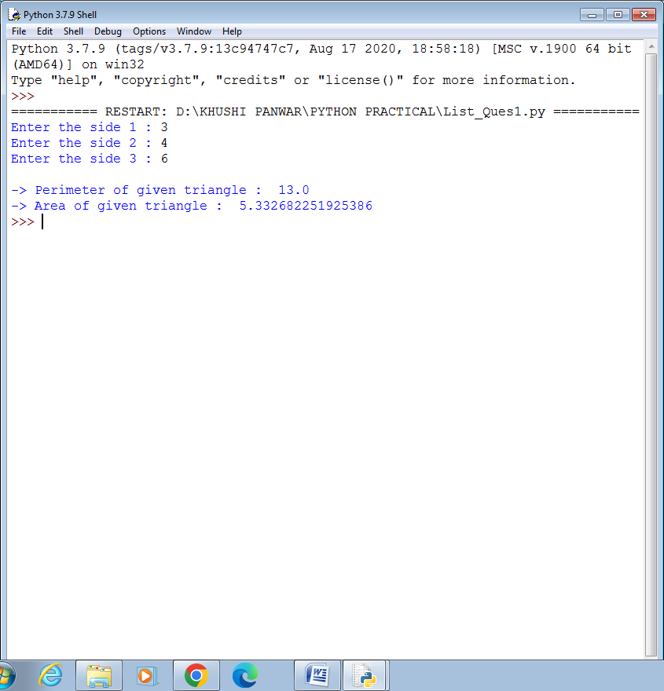

**Question 3 (From Practical List ) :**

**Solution →**

def factorial(n):

fact=1

for i in range(1,n+1):

fact=fact*i

return fact

def calc(n):

a=0

b=1

series=[a,b]

for i in range(0,n-2):

temp=a

a=b

b=temp+a

series.append(b)

num=series[n-1]

fact=factorial(num)

result=[series, num, fact]

return result

n=int(input("Enter the value of n (no. of terms) : "))

result=calc(n)

print()

print("-> The Fibonacci Series with ",n," terms : ", result[0] )

print("-> The nth term of Fibonacci Series is : ", result[1])

print("-> The factorial of nth term from above series is : ", result[2])

